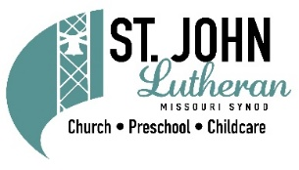

2022 Childcare Closings

April
15 Good Friday

May
30 Memorial Day

July
4 Independence Day

September
5 Labor Day

November
24 Thanksgiving
25 Thanksgiving Day after

December
23 Christmas Eve (observed)
26 Christmas Day (observed)
30 New Year’s Eve (observed)

January
2 New Year’s Day (observed)

